John H White MBE
Secretary
Prison Service Charity Fund
June 16th 2023

Dear John,

CHARITABLE DONATION

On behalf of all the Residents and Staff here at Broughton House, please accept our sincere thanks for your incredible generosity in choosing to grant us £2000 from the legacy of Mr Leo Edmund Queen.

We very much appreciate the fact that you have once again chosen to support our home.

Donations, such as this one, have played an increasingly crucial role, throughout the last few years, in ensuring that we can continue to provide a valued service to the veteran community.

We remain committed to delivering quality care to those who have served and are now in need of help and support. Over the next year, we plan to accommodate 64 veterans in our care home and to support 80 younger veterans through our community Support Hub. Our focus is to ensure that we can provide an environment that is comfortable, homely and where the needs of Residents are met in full.

Thank you for your support.

Yours sincerely,
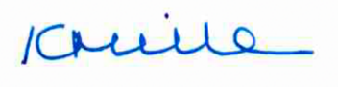

Karen Miller

Chief Executive

Broughton House Veteran Care Village

